Module 02 - Part 2: Hands-On Project 4-3: Viewing Digital Certificate Revocation Lists (CRLs) and Untrusted Certificates
Jadon Kosberg

Steps:
9: Expand Trusted Root Certification Authorities. These are the CAs approved for this computer. Scroll through this list. How many of these have you heard of before?
The only certificate I have heard of from the Trusted Root Certification Authorities is Microsoft Root Authority.
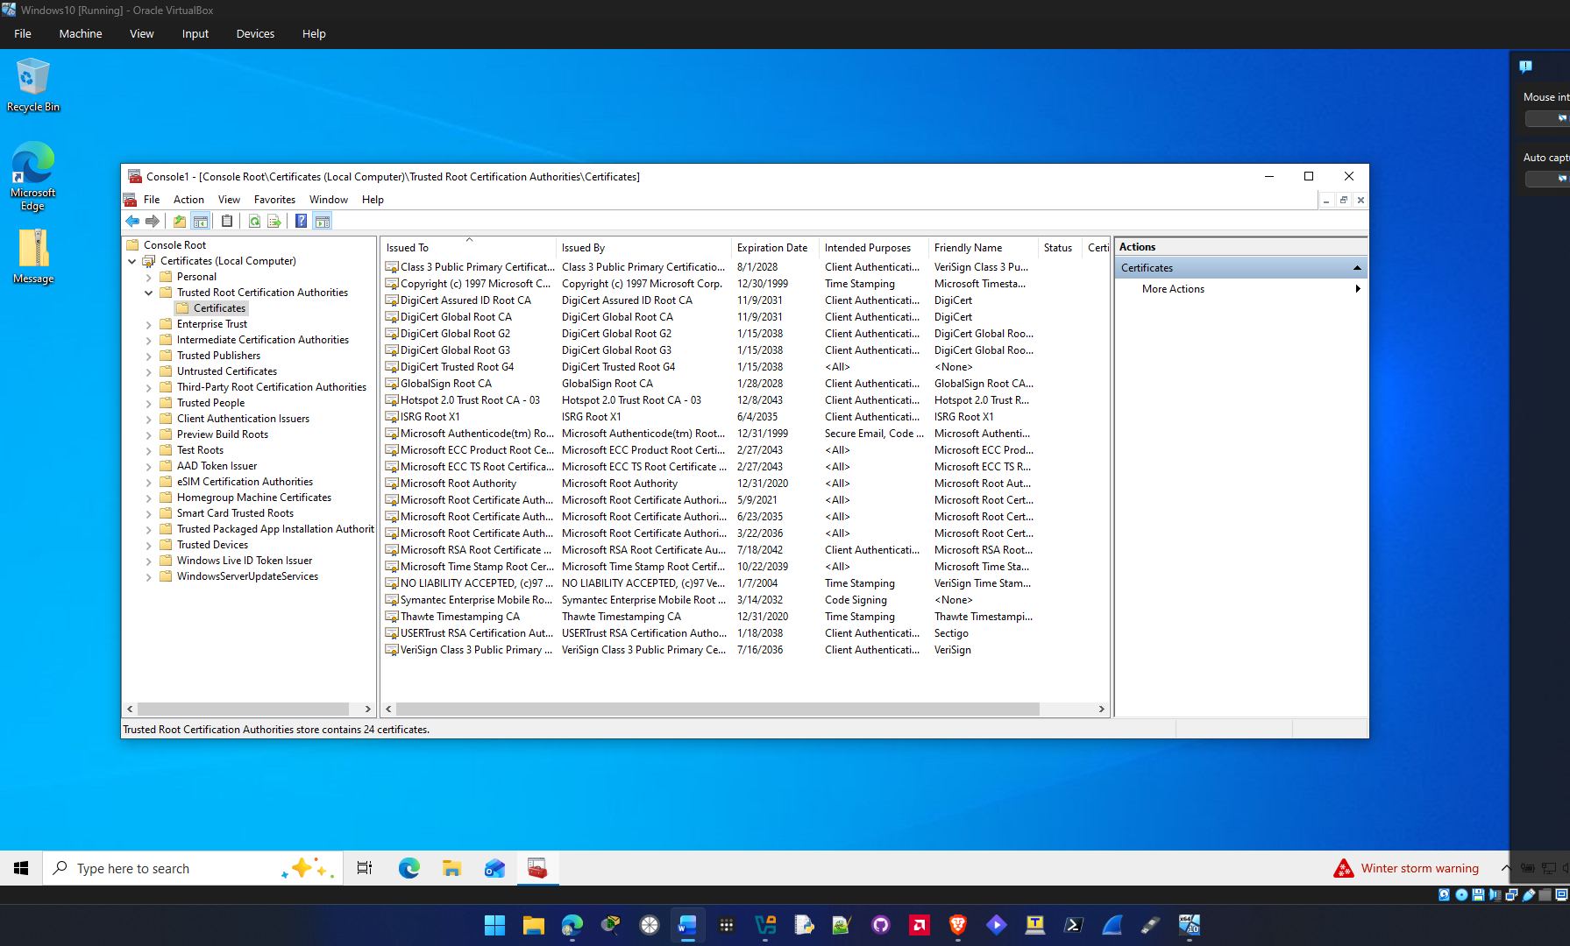

14: Read the information about it and click fields for more detail, if necessary. Why do you think this certificate has been revoked? Close the Certificate Revocation List by clicking the OK button.
It could be that the company went out of business or they never updated there digital certificate.
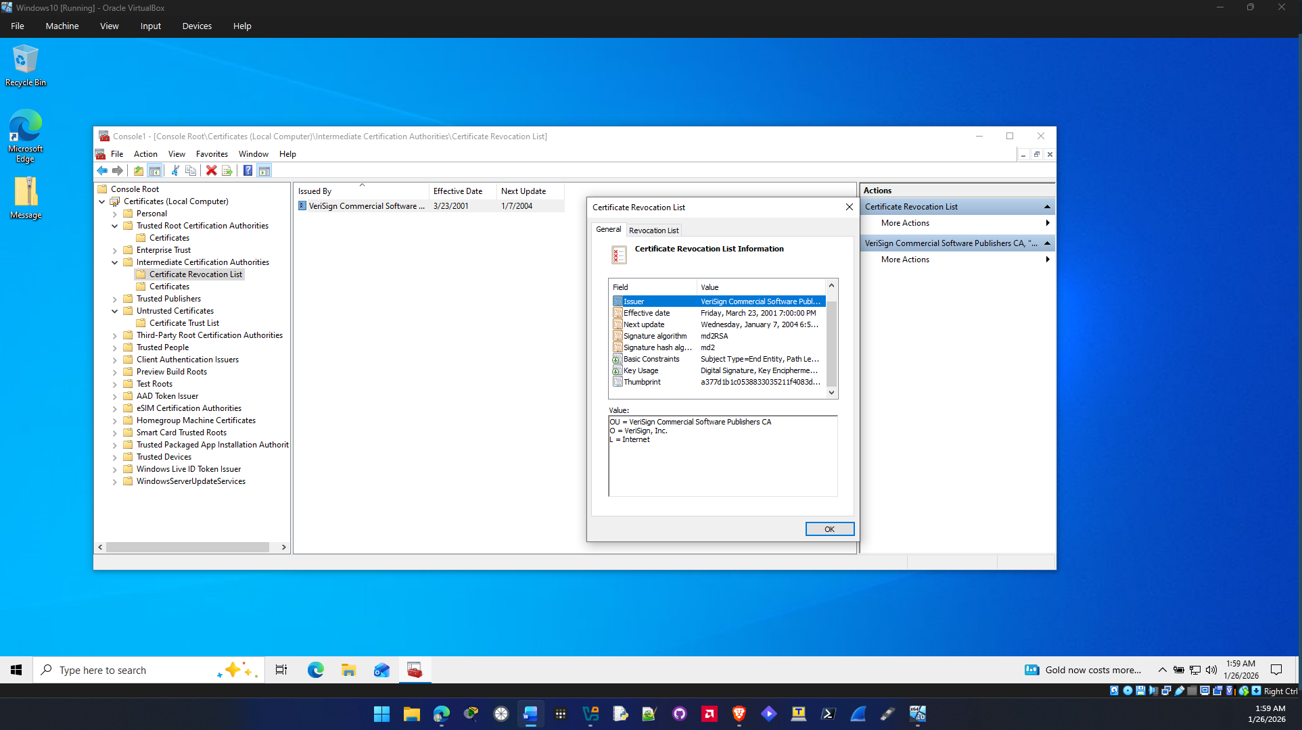

17: Double-click one of the untrusted certificates. Read the information about it and click fields for more detail, if necessary. Why do you think this certificate is no longer trusted?
A certificate can be no longer trusted because it has expired and needs renewed, cryptographic keys that are really old could cause an untrusted certificate, certificate revocation due to malicious activity could also cause an untrusted certificate.

